PROYECTO #1

Conceptos Avanzados de Software

|  |  |
| --- | --- |
| ALEJANDRA MARÍA CHICA RIVERA | Cód. 201522947 |
| DANIEL FELIPE RENTERÍA MARTÍNEZ | Cód. 201522630 |
| DEIVID ALEXANDER OSORIO BARRERA | Cód. 201523018 |
| DIEGO ANDRES MONTEALEGRE GARCIA | Cód. 201510727 |
| SEBASTIAN CARDONA CORREA | Cód. 201510311 |

Contenido

Contextualización 3

Lanzamiento de proyecto 4

Primera Acta de Equipo 6

Definición de equipo de proyecto 7

Objetivos del proyecto TSP 8

Objetivos por rol 9

Definición de alcance 10

El Plan de trabajo 11

Análisis de proceso 11

Modelo Conceptual 12

Estandar de codificación 13

Anexos 15

Anexo 1 INFO´S 15

Anexo 2 Shedule General 21

Anexo 3 Task General 22

# Contextualización

Como parte de la especialización de construcción de software se ha desarrollado dentro del espacio académico de Conceptos Avanzados de Software varios ejercicios donde cada integrante del equipo ha elaborado un producto siguiendo el proceso enmarcado en PSP, con sus respectivos formatos y obteniendo como resultado del ejercicio un estimado de tiempos y líneas de código efectivas por cada ingeniero.

Siguiendo esta metodología y con los conceptos de TSP se busca de manera práctica apropiar los conocimientos del proceso y tener el primer acercamiento a la metodología, formas y procesos de TSP.

Este es el resultado y análisis del primer ejercicio de TSP en el equipo Minmose Software, este proyecto tiene tres ciclos, 1 y 2 serán realizados en el equipo y en el ciclo 3 se enmarcarán los requerimientos funcionales que serán no serán desarrollados en esta especialización.

# Lanzamiento de proyecto

En la sesión del día 04 de Marzo de 2015 se realiza el lanzamiento del proyecto por parte del instructor Luis Daniel Benavides.

Los objetivos globales del proyecto se definieron en este lanzamiento y se enmarca en el siguiente enunciado de proyecto:

**The Program Analyzer Functional Need Statement**

The program analyzer is a software tool to help programmers determine the complexity of the programs they have developed. There is evidence, for example, that McCabe complexity, the coupling/strength ratio, and reachability are useful predictors of program quality. Therefore, these parameters may be of value to software developers when they design programs and later when they seek to modify, extend, or improve them. With the aid of these complexity data, development teams can identify components that likely have design problems.

They then can fix these problems before test.

1. **Program Analyzer Functions**

1.1 Analyze an existing program to determine its characteristics.

1.2 Count the program logical LOC and the LOC of each of its functions, procedures, or routines.

1.3 Calculate the program’s McCabe cyclomatic complexity and that of each of its functions, procedures, or routines [Schneidewind].

1.4 Calculate the program’s data bindings with its external environment and the data bindings of each of its functions, procedures, or routines [Selby].

1.5 Calculate the strength of the internal data bindings for the program and for each of its functions, procedures, or routines [Selby].

1.6 Determine the coupling/strength ratio of the overall program and of each of its functions, procedures, or routines [Selby].

1.7 Calculate the reachability of each of the program’s functions, procedures, or routines [Schneidewind].

1.8 Produce an analysis report that provides these calculated data in summary form.

1.9 Initially provide these functions for the language being used.

1.10 Enhance the program to analyze additional programming languages.

1. **Counting Specifications**

2.1 Have the LOC counter count text lines with a coding standard that requires one logical LOC to be placed on a single text line, as in PSP programs 2A and 3A. For further information on LOC counting, see *A Discipline for Software Engineering,* Chapter 4 [Humphrey 95].

2.2 As an added feature, enhance the program to fully analyze the program syntax and count logical LOC regardless of program format.

1. **Analyzer Specifications**

3.1 McCabe cyclomatic complexity *V* is calculated by V = (number of arcs) – (number of nodes) + 2

A *node* is a logic branch, and an *arc* is a program segment between branches.

There is an assumed arc from the program exit back to the program entry point.

3.2 Data binding, or coupling, is determined by counting the number of variables or parameters that a program shares with its external environment. If a program receives four input parameters and two variables and produces outputs for three different variables, its data binding value would be 4 + 2 + 3 = 9.

3.3 The internal binding strength of a program is determined by counting the binding among all the routines within that program. This internal strength is determined by counting the number of variable or parameter values passed among a program’s internal routines or procedures. For example, if a program has a total of 18 internal variables and parameters that are shared among its routines and procedures, its strength would be 18.

3.4 The coupling/strength ratio is the ratio of the numbers calculated in 3.2 and 3.3. In these examples, it would be 9/18 = 0.5. From a quality perspective, low values (such as 0.5) of this ratio are considered better than high ones (such as 2.3).

3.5 Reachability is calculated for each program node by counting the number of possible logical paths from the program or procedure entry to that node. Where a loop may be cycled several times, only one path is counted. The reachability of a program, function, or routine is calculated by averaging the reachability of all its nodes.

3.6 Although there are many ways to implement these analysis functions, many of the calculations and analyses are potentially language independent.

If you first produce a counter and a structural analyzer that are language-dependent, the remaining analyses can then be done once for all languages.

1. **General Specifications**

4.1 The program analyzer documentation must describe program installation and operation.

*Tomado del documento “Introduction to Team Software” de Humphrey, Watts.*

## Primera Acta de Equipo

A continuación se presenta la primera acta realizada posterior al lanzamiento del proyecto:

|  |  |  |  |
| --- | --- | --- | --- |
| Nombre quien realiza el acta: | Deivid Osorio | Fecha del acta: | 24/03/2015 |
| Nombre de moderador: | Deivid Osorio | Lugar de reunión: | Universidad de los Andes salón ML611 |
| Fecha de reunión: | 18/03/2015 | Hora de reunión: | 8:00 pm – 9:00 pm |

**Tema / Propósito de la reunión:**

El Objetivo de la reunión es repasar el lanzamiento del proyecto, los respectivos roles e identificar

del proyecto a realizar cada componente o funcionalidad a realizar para lograr hacer una

estimación inicial.

**Asistentes:**

|  |  |
| --- | --- |
| Nombre | Rol |
| Alejandra María Chica Rivera | Líder de desarrollo |
| Daniel Felipe Rentería Martínez | Líder de calidad |
| Deivid Alexander Osorio Barrera | Líder |
| Diego Andres Montealegre Garcia | Líder de planeación |
| Sebastian Cardona Correa | Líder de soporte |

**Agenda**

|  |  |  |  |  |
| --- | --- | --- | --- | --- |
| Tiempos (min.) | | | Temas | Líder de presentación |
| Plan | Inicio | Fin |
| 5 | 8:00pm | 8:05pm | Repaso de lanzamiento | Líder |
| 5 | 8:05pm | 8:10pm | Repaso de definición de roles | Líder |
| 20 | 8:10pm | 8:30pm | Diseño conceptual | Líder de desarrollo |
| 35 | 8:30pm | 9:05pm | Identificación de componentes y funcionalidades a trabajar identificando ciclo 1, 2 y 3 | Team |

# Definición de equipo de proyecto

Se definen los siguientes roles de equipo y sus respectivas responsabilidades según la teoría de TS

A continuación se detalla el equipo de proyecto conformado, indicando su rol asignado por cada fase del proyecto.

|  |  |  |  |
| --- | --- | --- | --- |
| Nombre | Rol ciclo 1 | Rol ciclo 2 | Horas por Semana |
| Alejandra Chica | Líder de Desarrollo | Líder de Calidad | 6h |
| Daniel Rentería | Líder de Calidad | Líder de Soporte | 6h |
| Diego Montealegre | Líder de Planeación | Líder de Desarrollo | 6h |
| Sebastian Cardona | Líder de Soporte | Líder de Equipo | 6h |
| Deivid Osorio | Líder de Equipo | Líder de Planeación | 6h |

# Objetivos del proyecto TSP

Objetivo 1: Producir un sistema de software con calidad

Métricas: Porcentaje de defectos encontrados antes de la primera compilación: 80%

Numero de defectos encontrados en las pruebas de sistema: 2

Requerimientos incluidos en el producto final: 100%

Objetivo 2: Realizar un proyecto bien administrado y productivo

Métricas: Error en la estimación del tamaño del producto < 20%

Error en la estimación del número de horas de desarrollo < 20%

Porcentaje de datos ingresados en la página de control del proyecto 100%

Objetivo 3: Finalizar a tiempo

Métrica: Días más temprano o más tarde de lo previsto para terminar un ciclo: < 4

# Objetivos por rol

En la primera sesión de equipo se definieron roles y fueron asignados a cada integrante basados en la información del formato INFO, estos formatos se encuentran en el Anexo 1 de este documento con el detalle de cada integrante.

Objetivos del líder de equipo

* Construir un equipo de trabajo confiable y efectivo
* Motivar a todos los miembros del equipo a participar en el desarrollo del proyecto
* Resolver los problemas que surgan en el trabajo de equipo
* Mantener al instructor informado de los avances semanales

Objetivos del líder de calidad

* Asegurar que todos los miembros del equipo utilizan de manera adecuada el proceso de PSP
* Realizar las inspecciones necesarias y reportarlas a tiempo para las reuniones de seguimiento con el instructor

Objetivos del líder de soporte

* Asegurar y equipar al equipo de proyecto de las herramientas necesarias para el desarrollo y control de los componentes asignados.
* Soportar y apoyar al equipo en los problemas que se presenten en cuanto al uso de las herramientas.

Objetivos del líder de desarrollo

* Producir un desarrollo que cumpla a satisfacción los requerimientos del usuario
* Desarrollar un modelo conceptual y técnico que permita soportar los requerimientos

Objetivos del líder de planeación

* Producir un plan adecuado y completo para el equipo y todos los miembros del mismo para desarrollar el proyecto
* Reportar de manera exacta el avance del proyecto

# Definición de alcance

La documentación del proceso de TSP indica que la definición del alcance del proyecto se acuerda en el formato STRAT el cual se adjunta a continuación y en donde hemos limitado los requerimientos del proyecto y se han asignado a un ciclo específico para su elaboración.

**TSPi Strategy Form - Form STRAT**

|  |  |  |  |  |  |  |  |  |  |  |  |  |
| --- | --- | --- | --- | --- | --- | --- | --- | --- | --- | --- | --- | --- |
| Name | | Deivid Osorio | | | Date | | | | 18/03/2015 | | | |
| Team | | Minmose Software | | | Instructor | | | | Daniel Benavides | | | |
| Part/Level | | Planeación | | | Cycle | | | | 1 | | | |
|  | |  | | | | |  | | |  | | | |
|  |  | | **Cycle LOC** | | | | | **Cycle Hours** | | | | |
| **Ref.** | **Functions** | | **1** | **2** | | **3** | | **1** | | | **2** | **3** |
| C1 | Vista | | X |  | |  | | X | | |  |  |
| C2 | Controlador | | X |  | |  | | X | | |  |  |
| C3 | Modelo | | X |  | |  | | X | | |  |  |
| C4 | Vista web | | 60 |  | |  | | 10 | | |  |  |
| C5 | Vista consola | | 30 |  | |  | | 5 | | |  |  |
| C6 | Controlador web | | 30 |  | |  | | 5 | | |  |  |
| C7 | Controlador consola | | 30 |  | |  | | 5 | | |  |  |
| F1 | Contador LOC | | 80 |  | |  | |  | | |  |  |
| F2 | Calculador complejidad ciclomática | |  | 80 | |  | |  | | |  |  |
| F3 | Calculador data bindigns Externos | |  | 80 | |  | |  | | | 133 |  |
| F4 | Calculador data bindigns Internos | | 80 |  | |  | |  | | | 133 |  |
| F5 | Calculador acoplamiento | |  | 60 | |  | |  | | | 10 |  |
| F6 | Calculador Reachability | |  |  | | X | |  | | |  | X |
| F7 | Reporte | |  | 40 | |  | |  | | | 66 |  |
| F8 | Soporte Program Languages | |  |  | | X | |  | | |  | X |
| F9 | Analizador | | 50 |  | |  | | 83 | | |  |  |
| F10 | Utilidades | | 50 | 50 | |  | | 83 | | | 83 |  |
|  |  | |  |  | |  | |  | | |  |  |
| **Totals** |  | | **3** | **310** | |  | | **416** | | | **515** |  |

Este formato nos permitió identificar y estimar cuáles requerimientos funcionales se van a desarrollar, el ciclo en el que serán desarrollados y el tiempo estimado de acuerdo a las líneas de código estimadas.

Es necesario indicar que la estimación se realizó con una base de 6 líneas de código efectivas por hora, esto basados en los resultados de los ejercicios de PSP de los miembros del equipo de proyecto.

# El Plan de trabajo

Una fase importante en la metodología de TSP es la generación del plan de trabajo en la cual se tiene como base el formato de shedule (Anexo 2) y task (Anexo 3) que se anexan al presente documento.

## Análisis de proceso

Parte de este plan de trabajo fue definir las actividades a realizar por cada integrante, esta fue la tarea que inicialmente se dificultó en el equipo de proyecto, esto porque la falta de experiencia en la planeación y en la metodología de TSP.

Posterior a la organización de las actividades a realizar y de la planeación realizada se identificaron las tareas a realizar para estabilizar el ciclo y poder cumplir con la entrega.

Dentro de nuestras actividades se identificaron los riesgos, los cuales fueron en marcados a esta fase de planeación y sus respectivas consecuencias de atraso en tiempo y falta de tiempo para corrección de errores e inspección de diseño, código y pruebas.

# Modelo Conceptual

Como parte de la fase de diseño se ha creado un modelo conceptual documentado en el formato de especificación de la metaforma y se ha construído el siguiente diagrama de modelo conceptual de la solución prouesta:

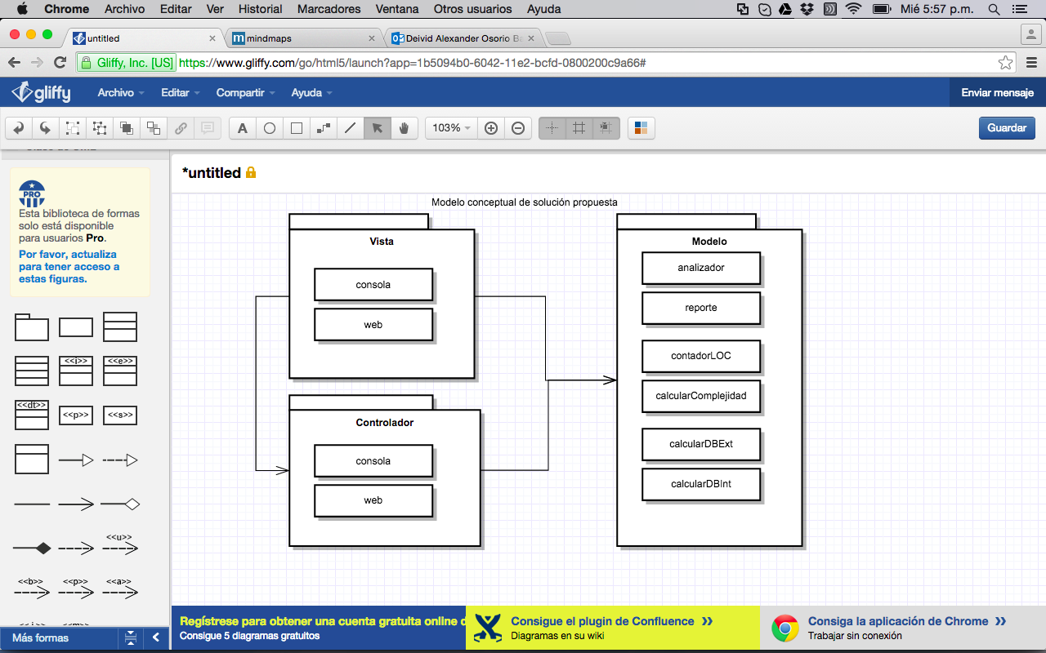

# Estandar de codificación

Se tomó el siguiente estándar de desarrollo para el programa y la codificación realizada, este fue tomado de los integrantes del equipo y del ejercicio de PSP:

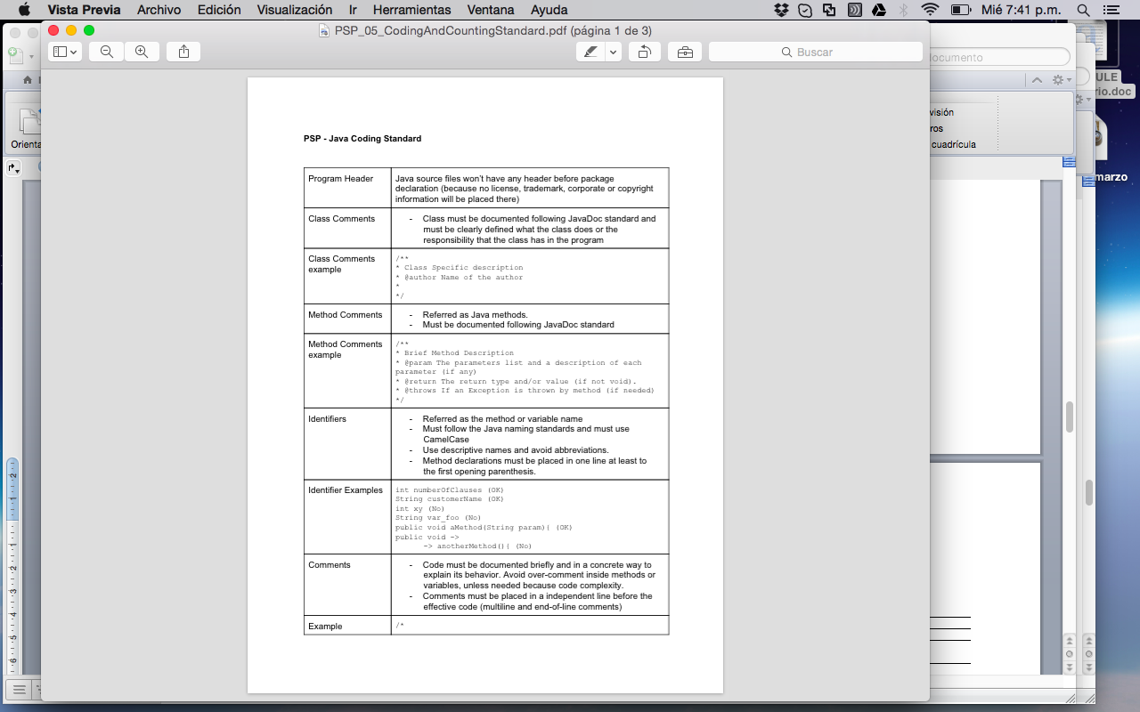

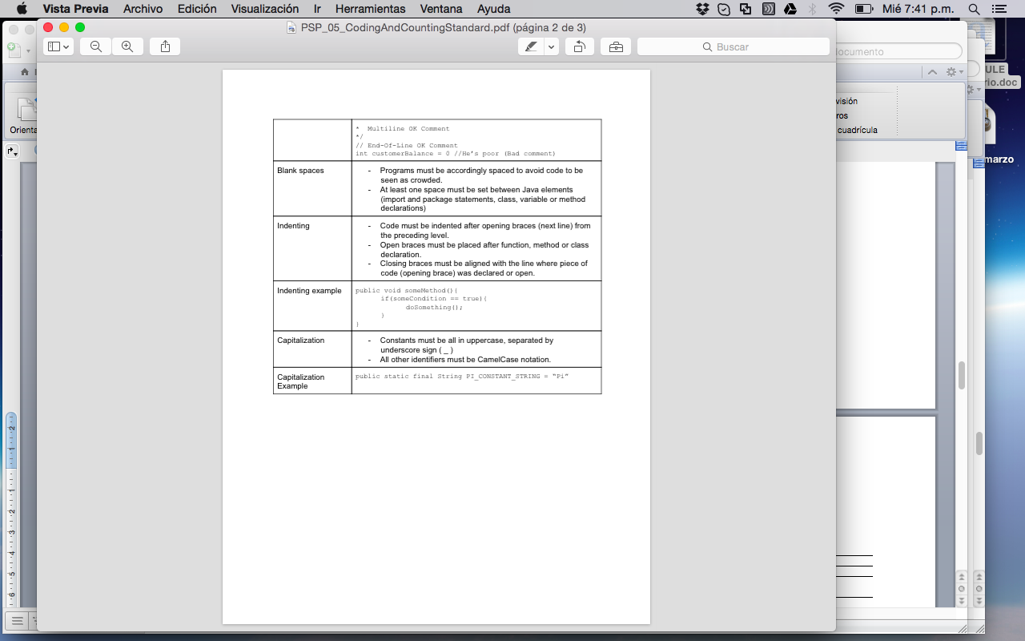

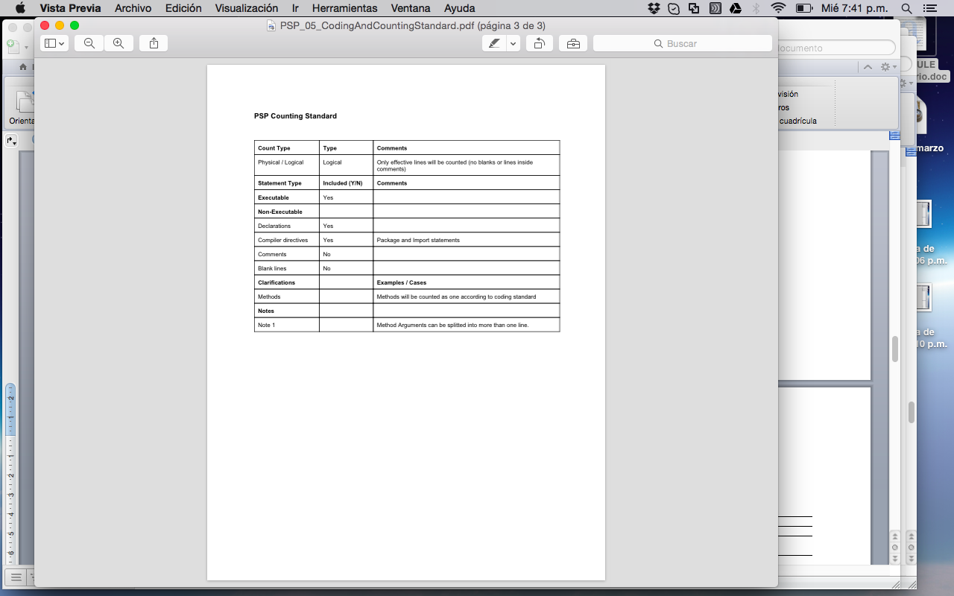

# Evaluación de metricas

Evaluación de métricas del objetivo

Producir un sistema de software con calidad

Métricas: Porcentaje de defectos encontrados antes de la primera compilación: 80%

Numero de defectos encontrados en las pruebas de sistema: 2

Requerimientos incluidos en el producto final: 100%

Objetivo 2: Realizar un proyecto bien administrado y productivo

Métricas: Error en la estimación del tamaño del producto < 20%

Error en la estimación del número de horas de desarrollo < 20%

Porcentaje de datos ingresados en la página de control del proyecto 100%

Objetivo 3: Finalizar a tiempo

Métrica: Días más temprano o más tarde de lo previsto para terminar un ciclo: < 4

# 

# Anexos

## Anexo 1 INFO´S

**TSPi Student Information Sheet - Form INFO**

|  |  |  |  |  |  |  |  |  |  |  |  |  |  |  |  |  |  |  |  |  |  |  |  |
| --- | --- | --- | --- | --- | --- | --- | --- | --- | --- | --- | --- | --- | --- | --- | --- | --- | --- | --- | --- | --- | --- | --- | --- |
| Name | Alejandra María Chica Rivera | | | | | | | | | Instructor | | | | | Luis Daniel Benavides | | | | | | | | |
| Date | 4 Marzo de 2015 | | | | Number of College Credits | | | | | | | | | | |  | | | | | | | |
| Major |  | | | | Expected Graduation Date | | | | | | | | | | |  | | | | | | | |
|  | | | | | | | |  | | | | |  | | | | |  | | | |  | |
| **Briefly describe your relevant experience and interests:** | | | | | | | | | | | | | | | | | | | | | | | |
| 4 años de desarrollo en Java, certificación java programmer, análisis y diseño de | | | | | | | | | | | | | | | | | | | | | | | |
| Aplicaciones | | | | | | | | | | | | | | | | | | | | | | | |
|  | | | | | | | | | | | | | | | | | | | | | | | |
| **Briefly describe your work on other team projects:** | | | | | | | | | | | | | | | | | | | | | | | |
| Gestión y soporte de la arquitectura | | | | | | | | | | | | | | | | | | | | | | | |
| Solución Bugs ambientes integracción y preproducción. | | | | | | | | | | | | | | | | | | | | | | | |
| Estimación de requerimientos | | | | | | | | | | | | | | | | | | | | | | | |
| **Briefly describe any leadership or management positions you have held (at work or in clubs/organizations):** | | | | | | | | | | | | | | | | | | | | | | | |
| Líder de desarrollo en proyectos | | | | | | | | | | | | | | | | | | | | | | | |
| Arquitectura | | | | | | | | | | | | | | | | | | | | | | | |
|  | | | | | | | | | | | | | | | | | | | | | | | |
| **State your team preferences, if any:** | | | | | | | | | | | | | | | | | | | | | | | |
|  | | | |  | | | | |  | | | | | |  | | | | |  | | | |
| List your class schedule and other times when you have scheduled activities such as work, ROTC, clubs, sports teams, etc. | | | | | | | | | | | | | | | | | | | | | | | |
| Time | | Mon. | Tue. | | | Wed. | | | | | Thu. | | | Fri. | | | | | Sat. | | | | Sun. |
| 800-900 | | **Work** | **Work** | | | **Work** | | | | | **Work** | | | **Work** | | | | |  | | | |  |
| 915-1015 | | **Work** | **Work** | | | **Work** | | | | | **Work** | | | **Work** | | | | |  | | | |  |
| 1030-1130 | | **Work** | **Work** | | | **Work** | | | | | **Work** | | | **Work** | | | | |  | | | |  |
| 1145-1245 | | **Work** | **Work** | | | **Work** | | | | | **Work** | | | **Work** | | | | |  | | | |  |
| 1300-1400 | | **Work** | **Work** | | | **Work** | | | | | **Work** | | | **Work** | | | | |  | | | |  |
| 1415-1515 | | **Work** | **Work** | | | **Work** | | | | | **Work** | | | **Work** | | | | |  | | | |  |
| 1530-1630 | | **Work** | **Work** | | | **Work** | | | | | **Work** | | | **Work** | | | | |  | | | |  |
| 1645-1745 | |  |  | | |  | | | | |  | | |  | | | | |  | | | |  |
| 1800-1900 | |  | **Study** | | | **Study** | | | | | **Study** | | |  | | | | |  | | | |  |
| 1915-2015 | |  | **Study** | | | **Study** | | | | | **Study** | | |  | | | | |  | | | |  |
| 2030-2130 | |  |  | | |  | | | | |  | | |  | | | | |  | | | |  |
| 2145-2245 | |  | **Study** | | | **Study** | | | | | **Study** | | |  | | | | |  | | | |  |
| 2300-0000 | |  | **Study** | | | **Study** | | | | | **Study** | | |  | | | | |  | | | |  |
|  | | | |  | | | | |  | | | | | |  | | | | |  | | | |
| Rank from 1 (least) to 5 (most) your preferences for serving in the following team roles: | | | | | | | | | | | | | | | | | | | | | | | |
| Team Leader | | | | **1** | | | **2** | | | | | **3** | | | | | **~~4~~** | | | | **5** | | |
| Development Manager | | | | **1** | | | **2** | | | | | **3** | | | | | **4** | | | | **5** | | |
| Planning Manager | | | | **1** | | | **2** | | | | | **3** | | | | | **4** | | | | **5** | | |
| Quality/Process Manager | | | | **1** | | | **2** | | | | | **3** | | | | | **4** | | | | **5** | | |
| Support Manager | | | | **1** | | | **2** | | | | | **3** | | | | | **4** | | | | **5** | | |

|  |  |  |  |  |  |  |  |  |  |  |  |  |  |  |  |  |  |  |  |  |  |  |  |
| --- | --- | --- | --- | --- | --- | --- | --- | --- | --- | --- | --- | --- | --- | --- | --- | --- | --- | --- | --- | --- | --- | --- | --- |
| Name | Daniel Felipe Rentería Martínez | | | | | | | | | Instructor | | | | | Luis Daniel Benavides | | | | | | | | |
| Date | 4 Marzo de 2015 | | | | Number of College Credits | | | | | | | | | | |  | | | | | | | |
| Major |  | | | | Expected Graduation Date | | | | | | | | | | | Marzo - 2016 | | | | | | | |
|  | | | | | | | |  | | | | |  | | | | |  | | | |  | |
| **Briefly describe your relevant experience and interests:** | | | | | | | | | | | | | | | | | | | | | | | |
| Mi experiencia principalmente se encuentra basada en diseño de components de software, así como en desarrollo bajo lenguaje de programación Java, PHP. Desarrollo de componentes y scripts para bases de datos MySQL y SQL Server. Análisis de requerimientos, diseño de software por componentes. | | | | | | | | | | | | | | | | | | | | | | | |
|  | | | | | | | | | | | | | | | | | | | | | | | |
| **Briefly describe your work on other team projects:** | | | | | | | | | | | | | | | | | | | | | | | |
| He trabajado en equipos de desarrollo para componentes backend, implementaciones y migraciones de proyectos que involucran productos ya existentes, así como mejoras de software. | | | | | | | | | | | | | | | | | | | | | | | |
|  | | | | | | | | | | | | | | | | | | | | | | | |
| **Briefly describe any leadership or management positions you have held (at work or in clubs/organizations):** | | | | | | | | | | | | | | | | | | | | | | | |
| Liderazgo del capítulo de geociencias de la IEEE Universidad Distrital en el año 2006. Liderazgo del equipo de proyectos de desarrollo y personalizaciones en Etek International | | | | | | | | | | | | | | | | | | | | | | | |
|  | | | | | | | | | | | | | | | | | | | | | | | |
| **State your team preferences, if any:** | | | | | | | | | | | | | | | | | | | | | | | |
| Me gustaría la parte de diseño o planeación. | | | | | | | | | | | | | | | | | | | | | | | |
|  | | | |  | | | | |  | | | | | |  | | | | |  | | | |
| List your class schedule and other times when you have scheduled activities such as work, ROTC, clubs, sports teams, etc. | | | | | | | | | | | | | | | | | | | | | | | |
| Time | | Mon. | Tue. | | | Wed. | | | | | Thu. | | | Fri. | | | | | Sat. | | | | Sun. |
| 800-900 | | **Work** | **Work** | | | **Work** | | | | | **Work** | | | **Work** | | | | |  | | | |  |
| 915-1015 | | **Work** | **Work** | | | **Work** | | | | | **Work** | | | **Work** | | | | |  | | | |  |
| 1030-1130 | | **Work** | **Work** | | | **Work** | | | | | **Work** | | | **Work** | | | | |  | | | |  |
| 1145-1245 | | **Work** | **Work** | | | **Work** | | | | | **Work** | | | **Work** | | | | |  | | | |  |
| 1300-1400 | | **Work** | **Work** | | | **Work** | | | | | **Work** | | | **Work** | | | | |  | | | |  |
| 1415-1515 | | **Work** | **Work** | | | **Work** | | | | | **Work** | | | **Work** | | | | |  | | | |  |
| 1530-1630 | | **Work** | **Work** | | | **Work** | | | | | **Work** | | | **Work** | | | | |  | | | |  |
| 1645-1745 | | **Work** | **Work** | | | **Work** | | | | | **Work** | | | **Work** | | | | |  | | | |  |
| 1800-1900 | |  | **Study** | | | **Study** | | | | | **Study** | | |  | | | | |  | | | |  |
| 1915-2015 | |  | **Study** | | | **Study** | | | | | **Study** | | |  | | | | |  | | | |  |
| 2030-2130 | |  |  | | |  | | | | |  | | |  | | | | |  | | | |  |
| 2145-2245 | |  | **Study** | | | **Study** | | | | | **Study** | | |  | | | | |  | | | |  |
| 2300-0000 | |  | **Study** | | | **Study** | | | | | **Study** | | |  | | | | |  | | | |  |
|  | | | |  | | | | |  | | | | | |  | | | | |  | | | |
| Rank from 1 (least) to 5 (most) your preferences for serving in the following team roles: | | | | | | | | | | | | | | | | | | | | | | | |
| Team Leader | | | | **1** | | | **2** | | | | | **3** | | | | | **~~4~~** | | | | **5** | | |
| Development Manager | | | | **1** | | | **2** | | | | | **3** | | | | | **4** | | | | **5** | | |
| Planning Manager | | | | **1** | | | **2** | | | | | **3** | | | | | **4** | | | | **5** | | |
| Quality/Process Manager | | | | **1** | | | **2** | | | | | **3** | | | | | **4** | | | | **5** | | |
| Support Manager | | | | **1** | | | **2** | | | | | **3** | | | | | **4** | | | | **5** | | |

**TSPi Student Information Sheet - Form INFO**

|  |  |  |  |  |  |  |  |  |  |  |  |  |  |  |  |  |  |  |  |  |  |  |  |
| --- | --- | --- | --- | --- | --- | --- | --- | --- | --- | --- | --- | --- | --- | --- | --- | --- | --- | --- | --- | --- | --- | --- | --- |
| Name | Deivid Alexander Osorio Barrera | | | | | | | | | Instructor | | | | | Luis Daniel Benavides | | | | | | | | |
| Date | 4 Marzo de 2015 | | | | Number of College Credits | | | | | | | | | | |  | | | | | | | |
| Major |  | | | | Expected Graduation Date | | | | | | | | | | |  | | | | | | | |
|  | | | | | | | |  | | | | |  | | | | |  | | | |  | |
| **Briefly describe your relevant experience and interests:** | | | | | | | | | | | | | | | | | | | | | | | |
| Experiencia en desarrollo de aplicativos web, líder de equipos de desarrollo y encargado | | | | | | | | | | | | | | | | | | | | | | | |
| de mantenimiento, desarrollo y mejoras de aplicativos. | | | | | | | | | | | | | | | | | | | | | | | |
| Experiencia en proyectos de desarrollo de software de 2 años. | | | | | | | | | | | | | | | | | | | | | | | |
| **Briefly describe your work on other team projects:** | | | | | | | | | | | | | | | | | | | | | | | |
| Coordinación de equipo de trabajo para soporte, diseño y seguimiento de desarrollo de | | | | | | | | | | | | | | | | | | | | | | | |
| Requerimientos en aplicativos web. | | | | | | | | | | | | | | | | | | | | | | | |
|  | | | | | | | | | | | | | | | | | | | | | | | |
| **Briefly describe any leadership or management positions you have held (at work or in clubs/organizations):** | | | | | | | | | | | | | | | | | | | | | | | |
|  | | | | | | | | | | | | | | | | | | | | | | | |
| Líder de aplicativos web | | | | | | | | | | | | | | | | | | | | | | | |
| Líder técnico en proyecto asignado | | | | | | | | | | | | | | | | | | | | | | | |
| **State your team preferences, if any:** | | | | | | | | | | | | | | | | | | | | | | | |
|  | | | | | | | | | | | | | | | | | | | | | | | |
|  | | | |  | | | | |  | | | | | |  | | | | |  | | | |
| List your class schedule and other times when you have scheduled activities such as work, ROTC, clubs, sports teams, etc. | | | | | | | | | | | | | | | | | | | | | | | |
| Time | | Mon. | Tue. | | | Wed. | | | | | Thu. | | | Fri. | | | | | Sat. | | | | Sun. |
| 800-900 | | **Work** | **Work** | | | **Work** | | | | | **Work** | | | **Work** | | | | |  | | | |  |
| 915-1015 | | **Work** | **Work** | | | **Work** | | | | | **Work** | | | **Work** | | | | |  | | | |  |
| 1030-1130 | | **Work** | **Work** | | | **Work** | | | | | **Work** | | | **Work** | | | | |  | | | |  |
| 1145-1245 | | **Work** | **Work** | | | **Work** | | | | | **Work** | | | **Work** | | | | |  | | | |  |
| 1300-1400 | | **Work** | **Work** | | | **Work** | | | | | **Work** | | | **Work** | | | | |  | | | |  |
| 1415-1515 | | **Work** | **Work** | | | **Work** | | | | | **Work** | | | **Work** | | | | |  | | | |  |
| 1530-1630 | | **Work** | **Work** | | | **Work** | | | | | **Work** | | | **Work** | | | | |  | | | |  |
| 1645-1745 | |  |  | | |  | | | | |  | | |  | | | | |  | | | |  |
| 1800-1900 | |  | **Study** | | | **Study** | | | | | **Study** | | |  | | | | |  | | | |  |
| 1915-2015 | |  | **Study** | | | **Study** | | | | | **Study** | | |  | | | | |  | | | |  |
| 2030-2130 | |  |  | | |  | | | | |  | | |  | | | | |  | | | |  |
| 2145-2245 | |  | **Study** | | | **Study** | | | | | **Study** | | |  | | | | |  | | | |  |
| 2300-0000 | |  | **Study** | | | **Study** | | | | | **Study** | | |  | | | | |  | | | |  |
|  | | | |  | | | | |  | | | | | |  | | | | |  | | | |
| Rank from 1 (least) to 5 (most) your preferences for serving in the following team roles: | | | | | | | | | | | | | | | | | | | | | | | |
| Team Leader | | | | **1** | | | **2** | | | | | **3** | | | | | **~~4~~** | | | | **5** | | |
| Development Manager | | | | **1** | | | **2** | | | | | **3** | | | | | **4** | | | | **5** | | |
| Planning Manager | | | | **1** | | | **2** | | | | | **3** | | | | | **4** | | | | **5** | | |
| Quality/Process Manager | | | | **1** | | | **2** | | | | | **3** | | | | | **4** | | | | **5** | | |
| Support Manager | | | | **1** | | | **2** | | | | | **3** | | | | | **4** | | | | **5** | | |

**TSPi Student Information Sheet - Form INFO**

|  |  |  |  |  |  |  |  |  |  |  |  |  |  |  |  |  |  |  |  |  |  |  |  |
| --- | --- | --- | --- | --- | --- | --- | --- | --- | --- | --- | --- | --- | --- | --- | --- | --- | --- | --- | --- | --- | --- | --- | --- |
| Name | Diego Andrés Montealegre García | | | | | | | | | Instructor | | | | | Luis Daniel Benavides | | | | | | | | |
| Date | 4 Marzo de 2015 | | | | Number of College Credits | | | | | | | | | | |  | | | | | | | |
| Major |  | | | | Expected Graduation Date | | | | | | | | | | |  | | | | | | | |
|  | | | | | | | |  | | | | |  | | | | |  | | | |  | |
| **Briefly describe your relevant experience and interests:** | | | | | | | | | | | | | | | | | | | | | | | |
| 3 años de experiencia de desarrollo, en plataformas .net c#, java, trabajando en el area de | | | | | | | | | | | | | | | | | | | | | | | |
| portales transaccionales pero diferentes empresas | | | | | | | | | | | | | | | | | | | | | | | |
|  | | | | | | | | | | | | | | | | | | | | | | | |
| **Briefly describe your work on other team projects:** | | | | | | | | | | | | | | | | | | | | | | | |
| Ingeniero de desarrollo, levantamiento de requerimientos, en desarrollo. | | | | | | | | | | | | | | | | | | | | | | | |
| He trabajado como líder técnico, seguimiento a los desarrolladores funcionalmente | | | | | | | | | | | | | | | | | | | | | | | |
|  | | | | | | | | | | | | | | | | | | | | | | | |
| **Briefly describe any leadership or management positions you have held (at work or in clubs/organizations):** | | | | | | | | | | | | | | | | | | | | | | | |
| En proyecto como líder técnico y como líder del proyecto de he presentado inconvenientes | | | | | | | | | | | | | | | | | | | | | | | |
| con los clientes que cambiaban o que se cambia el requerimiento sin hacer el respectivo | | | | | | | | | | | | | | | | | | | | | | | |
| seguimiento | | | | | | | | | | | | | | | | | | | | | | | |
| **State your team preferences, if any:** | | | | | | | | | | | | | | | | | | | | | | | |
|  | | | | | | | | | | | | | | | | | | | | | | | |
|  | | | |  | | | | |  | | | | | |  | | | | |  | | | |
| List your class schedule and other times when you have scheduled activities such as work, ROTC, clubs, sports teams, etc. | | | | | | | | | | | | | | | | | | | | | | | |
| Time | | Mon. | Tue. | | | Wed. | | | | | Thu. | | | Fri. | | | | | Sat. | | | | Sun. |
| 800-900 | | **Work** | **Work** | | | **Work** | | | | | **Work** | | | **Work** | | | | |  | | | |  |
| 915-1015 | | **Work** | **Work** | | | **Work** | | | | | **Work** | | | **Work** | | | | |  | | | |  |
| 1030-1130 | | **Work** | **Work** | | | **Work** | | | | | **Work** | | | **Work** | | | | |  | | | |  |
| 1145-1245 | | **Work** | **Work** | | | **Work** | | | | | **Work** | | | **Work** | | | | |  | | | |  |
| 1300-1400 | | **Work** | **Work** | | | **Work** | | | | | **Work** | | | **Work** | | | | |  | | | |  |
| 1415-1515 | | **Work** | **Work** | | | **Work** | | | | | **Work** | | | **Work** | | | | |  | | | |  |
| 1530-1630 | | **Work** | **Work** | | | **Work** | | | | | **Work** | | | **Work** | | | | |  | | | |  |
| 1645-1745 | |  |  | | |  | | | | |  | | |  | | | | |  | | | |  |
| 1800-1900 | |  | **Study** | | | **Study** | | | | | **Study** | | |  | | | | |  | | | |  |
| 1915-2015 | |  | **Study** | | | **Study** | | | | | **Study** | | |  | | | | |  | | | |  |
| 2030-2130 | |  |  | | |  | | | | |  | | |  | | | | |  | | | |  |
| 2145-2245 | |  | **Study** | | | **Study** | | | | | **Study** | | |  | | | | |  | | | |  |
| 2300-0000 | |  | **Study** | | | **Study** | | | | | **Study** | | |  | | | | |  | | | |  |
|  | | | |  | | | | |  | | | | | |  | | | | |  | | | |
| Rank from 1 (least) to 5 (most) your preferences for serving in the following team roles: | | | | | | | | | | | | | | | | | | | | | | | |
| Team Leader | | | | **1** | | | **2** | | | | | **3** | | | | | **~~4~~** | | | | **5** | | |
| Development Manager | | | | **1** | | | **2** | | | | | **3** | | | | | **4** | | | | **5** | | |
| Planning Manager | | | | **1** | | | **2** | | | | | **3** | | | | | **4** | | | | **5** | | |
| Quality/Process Manager | | | | **1** | | | **2** | | | | | **3** | | | | | **4** | | | | **5** | | |
| Support Manager | | | | **1** | | | **2** | | | | | **3** | | | | | **4** | | | | **5** | | |

**TSPi Student Information Sheet - Form INFO**

|  |  |  |  |  |  |  |  |  |  |  |  |  |  |  |  |  |  |  |  |  |  |  |  |
| --- | --- | --- | --- | --- | --- | --- | --- | --- | --- | --- | --- | --- | --- | --- | --- | --- | --- | --- | --- | --- | --- | --- | --- |
| Name | Sebastian Cardona Correa | | | | | | | | | Instructor | | | | | Luis Daniel Benavides | | | | | | | | |
| Date | 4 Marzo de 2015 | | | | Number of College Credits | | | | | | | | | | |  | | | | | | | |
| Major |  | | | | Expected Graduation Date | | | | | | | | | | |  | | | | | | | |
|  | | | | | | | |  | | | | |  | | | | |  | | | |  | |
| **Briefly describe your relevant experience and interests:** | | | | | | | | | | | | | | | | | | | | | | | |
| Mi experiencia ha sido como desarrollador y luego como TL, me interesa que exista una | | | | | | | | | | | | | | | | | | | | | | | |
| sinergia entre los objetivos del proyecto y los intereses particulares del equipo. | | | | | | | | | | | | | | | | | | | | | | | |
|  | | | | | | | | | | | | | | | | | | | | | | | |
| **Briefly describe your work on other team projects:** | | | | | | | | | | | | | | | | | | | | | | | |
| Encargado de gestionar y liderar toda la cadena de sdlk incluyendo la integración para un | | | | | | | | | | | | | | | | | | | | | | | |
| equipo de soporte de aplicaciones. | | | | | | | | | | | | | | | | | | | | | | | |
|  | | | | | | | | | | | | | | | | | | | | | | | |
| **Briefly describe any leadership or management positions you have held (at work or in clubs/organizations):** | | | | | | | | | | | | | | | | | | | | | | | |
| Creador del semillero de software libre en la Universidad de Caldas donde se logró la | | | | | | | | | | | | | | | | | | | | | | | |
| creación de una revista de estudiantes. | | | | | | | | | | | | | | | | | | | | | | | |
|  | | | | | | | | | | | | | | | | | | | | | | | |
| **State your team preferences, if any:** | | | | | | | | | | | | | | | | | | | | | | | |
|  | | | | | | | | | | | | | | | | | | | | | | | |
|  | | | |  | | | | |  | | | | | |  | | | | |  | | | |
| List your class schedule and other times when you have scheduled activities such as work, ROTC, clubs, sports teams, etc. | | | | | | | | | | | | | | | | | | | | | | | |
| Time | | Mon. | Tue. | | | Wed. | | | | | Thu. | | | Fri. | | | | | Sat. | | | | Sun. |
| 800-900 | | **Work** | **Work** | | | **Work** | | | | | **Work** | | | **Work** | | | | |  | | | |  |
| 915-1015 | | **Work** | **Work** | | | **Work** | | | | | **Work** | | | **Work** | | | | |  | | | |  |
| 1030-1130 | | **Work** | **Work** | | | **Work** | | | | | **Work** | | | **Work** | | | | |  | | | |  |
| 1145-1245 | | **Work** | **Work** | | | **Work** | | | | | **Work** | | | **Work** | | | | |  | | | |  |
| 1300-1400 | | **Work** | **Work** | | | **Work** | | | | | **Work** | | | **Work** | | | | |  | | | |  |
| 1415-1515 | | **Work** | **Work** | | | **Work** | | | | | **Work** | | | **Work** | | | | |  | | | |  |
| 1530-1630 | | **Work** | **Work** | | | **Work** | | | | | **Work** | | | **Work** | | | | |  | | | |  |
| 1645-1745 | |  |  | | |  | | | | |  | | |  | | | | |  | | | |  |
| 1800-1900 | |  | **Study** | | | **Study** | | | | | **Study** | | |  | | | | |  | | | |  |
| 1915-2015 | |  | **Study** | | | **Study** | | | | | **Study** | | |  | | | | |  | | | |  |
| 2030-2130 | |  |  | | |  | | | | |  | | |  | | | | |  | | | |  |
| 2145-2245 | |  | **Study** | | | **Study** | | | | | **Study** | | |  | | | | |  | | | |  |
| 2300-0000 | |  | **Study** | | | **Study** | | | | | **Study** | | |  | | | | |  | | | |  |
|  | | | |  | | | | |  | | | | | |  | | | | |  | | | |
| Rank from 1 (least) to 5 (most) your preferences for serving in the following team roles: | | | | | | | | | | | | | | | | | | | | | | | |
| Team Leader | | | | **1** | | | **2** | | | | | **3** | | | | | **~~4~~** | | | | **5** | | |
| Development Manager | | | | **1** | | | **2** | | | | | **3** | | | | | **4** | | | | **5** | | |
| Planning Manager | | | | **1** | | | **2** | | | | | **3** | | | | | **4** | | | | **5** | | |
| Quality/Process Manager | | | | **1** | | | **2** | | | | | **3** | | | | | **4** | | | | **5** | | |
| Support Manager | | | | **1** | | | **2** | | | | | **3** | | | | | **4** | | | | **5** | | |

## Anexo 2 Shedule General

**TSPi Schedule Planning Template - Form SCHEDULE**

|  |  |  |  |  |  |  |  |  |  |  |  |
| --- | --- | --- | --- | --- | --- | --- | --- | --- | --- | --- | --- |
| Name | | Team | | | | | Date | | 31/03/2015 | | |
| Team | | Minmose Software | | | | | Instructor | | Luis Daniel Benavides | | |
| Part/Level | | PLAN | | | | | Cycle | | 1 | | |
|  | | | | | | | | | | | |
|  |  | | **Plan** | | | **Actual** | | | | | |
| **Week**  **No.** | **Date** | | **Direct**  **Hours** | **Cumulative**  **Hours** | **Cumulative**  **Planned**  **Value** | **Team**  **Hours** | | **Cumulative**  **Hours** | | **Week**  **Earned Value** | **Cumulative**  **Earned Value** |
| 1 | 21/03/2015 | | 10 | 10 | 7,1 |  | |  | |  |  |
| 3 | 04/04/2015 | | 25 | 35 | 27,7 |  | |  | |  |  |
| 4 | 11/04/2015 | | 80 | 115 | 74,9 |  | |  | |  |  |
| 5 | 18/04/2015 | | 27 | 142 | 100 |  | |  | |  |  |
|  |  | |  |  |  |  | |  | |  |  |
|  |  | |  |  |  |  | |  | |  |  |

## Anexo 3 Task General

|  |  |  |  |  |  |  |  |  |  |  |  |  |  |  |  |  |  |  |
| --- | --- | --- | --- | --- | --- | --- | --- | --- | --- | --- | --- | --- | --- | --- | --- | --- | --- | --- |
| **Task** | | | | **Plan Hours** | | | | | | | **Plan Size/Value** | | | | | **Actual** | | |
| **Phase** | **Part** | **Task Name** | **# Engineers** | **Team Leader** | **Development Manager** | **Planning Manager** | **Qual./Proc. Manager** | **Support Manager** | **Total Team Hours** | **Cumulative**  **Hours** | **Size Units** | **Size** | **Week No.** | **Planned Value** | **Cumulative**  **PV** | **Hours** | **Cumulative Hours** | **Week No.** |
| LAU |  | Definir Objetivos de proyecto | 5 | 1 | 1 | 1 | 1 | 1 | 5 | 5 | PAGE | 2 | 1 | 3,5 | 3,5 |  |  |  |
| LAU |  | Diligenciar Info Form de cada integrante del equipo | 5 | 0,5 | 0,5 | 0,5 | 0,5 | 0,5 | 2,5 | 7,5 | PAGE | 5 | 1 | 1,8 | 5,3 |  |  |  |
| LAU |  | Asignar roles | 5 | 0,5 | 0,5 | 0,5 | 0,5 | 0,5 | 2,5 | 10 | PAGE | 5 | 1 | 1,8 | 7,1 |  |  |  |
| STRAT |  | Crear el diseño Conceptual macro | 5 | 0,5 | 1 | 0,5 | 0,5 | 0,5 | 2,5 | 12,5 | PAGE | 5 | 3 | 1,8 | 8,9 |  |  |  |
| STRAT |  | Establecer la estrategia | 5 | 1 | 1 | 1 | 1 | 1 | 5 | 17,5 | PAGE | 1 | 3 | 3,5 | 12,4 |  |  |  |
| STRAT |  | Realizar estimaciones de tamaño y tiempo según la estrategia | 5 | 0,5 | 0,5 | 0,5 | 0,5 | 0,5 | 2,5 | 20 | PAGE | 5 | 3 | 1,8 | 14,2 |  |  |  |
| STRAT |  | Identificar riesgos del Proyecto | 1 | 1 | 0 | 0 | 0 | 0 | 1 | 21 | PAGE | 2 | 3 | 0,7 | 14,9 |  |  |  |
| STRAT |  | Socialización y validación del diseño conceptual | 5 | 0,5 | 0,5 | 0,5 | 0,5 | 0,5 | 2,5 | 23,5 |  |  | 3 | 1,8 | 16,7 |  |  |  |
| STRAT |  | Generar acta de reunión con diseño conceptual y roles | 1 | 0 | 0 | 0 | 0,5 | 0 | 0,5 | 24 | PAGE | 2 | 3 | 0,4 | 17,1 |  |  |  |
| STRAT |  | Crear herramientas de implementación y control de versiones | 1 | 0 | 0 | 0 | 0 | 1 | 1 | 25 | PAGE | 1 | 3 | 0,7 | 17,8 |  |  |  |
| PLAN |  | Generar listado de tareas del ciclo | 5 | 0,5 | 0,5 | 1 | 0,5 | 0,5 | 3 | 28 | PAGE | 2 | 3 | 2,1 | 19,9 |  |  |  |
| PLAN |  | Crear el plan de desarrollo del proyecto | 5 | 0,5 | 1 | 1 | 0,5 | 0,5 | 3,5 | 31,5 | PAGE | 2 | 3 | 2,5 | 22,4 |  |  |  |
| PLAN |  | Realizar plan de calidad(Definir estándares) | 5 | 0,3 | 0,5 | 0,5 | 1 | 0,5 | 2,8 | 34,2 | PAGE | 2 | 3 | 2 | 24,4 |  |  |  |
| REQ |  | Requerimientos funcionales | 3 | 1 | 2 | 2 | 0 | 0 | 5 | 39,2 | PAGE | 2 | 3 | 3,5 | 27,9 |  |  |  |
| REQ |  | Definir interfaz de Usuario | 3 | 1 | 1 | 1 | 0 | 0 | 3 | 42,2 | PAGE | 1 | 3 | 2,1 | 30 |  |  |  |
| REQ |  | Diseño de alto nivel | 2 | 0 | 1 | 1 | 0 | 0 | 2 | 45,2 | PAGE | 1 | 3 | 1,4 | 31,4 |  |  |  |
| REQ |  | Revisar e inspeccionar los requerimientos | 5 | 1 | 0,5 | 0,5 | 0,5 | 0,5 | 3 | 47,2 |  |  | 3 | 2,1 | 33,5 |  |  |  |
| PLAN |  | Crear el plan de pruebas | 2 | 1 | 0 | 1 | 0 | 0 | 2 | 49,2 | PAGE | 2 | 3 | 1,4 | 34,9 |  |  |  |
| DESIGN |  | Diseño detallado | 2 | 0 | 0,5 | 0,5 | 0 | 0 | 1 | 50,2 | PAGE | 3 | 3 | 0,7 | 35,6 |  |  |  |
| DESIGN |  | Revisión de diseño detallado | 5 | 0,5 | 0,5 | 0,5 | 0,5 | 0,5 | 2,5 | 52,7 | PAGE |  | 3 | 1,8 | 37,4 |  |  |  |
| DESING |  | Inspección del plan de pruebas | 3 | 0,3 | 0 | 0,5 | 0,5 | 0 | 1,3 | 54 | PAGE |  | 3 | 0,9 | 38,3 |  |  |  |
| CODE |  | Generar código o solución | 2 | 0 | 1 | 0 | 0 | 1 | 2 | 56 | LOC | 20 | 3 | 1,4 | 39,7 |  |  |  |
| CODE |  | Implementar clases y objetos | 5 | 8,5 | 8,5 | 8,5 | 8,5 | 8,5 | 42,5 | 98,5 | LOC | 390 | 3 | 29,9 | 69,6 |  |  |  |
| CODE |  | Revisar e inspeccionar el código | 3 | 0,5 | 1 | 0 | 1 | 0 | 2,5 | 100,5 |  |  | 3 | 1,8 | 71,4 |  |  |  |
| CODE |  | Ajustar código | 5 | 1 | 1 | 1 | 1 | 1 | 5 | 105,5 |  |  | 3 | 3,5 | 74,9 |  |  |  |
| CODE |  | Ejecutar pruebas unitarias | 5 | 1 | 1 | 1 | 1 | 1 | 5 | 110,5 | PAGE | 5 | 3 | 3,5 | 78,4 |  |  |  |
| CODE |  | Realizar check in en github | 5 | 0,5 | 0,5 | 0,5 | 0,5 | 0,5 | 2,5 | 113 |  |  | 4 | 1,8 | 80,2 |  |  |  |
| TEST |  | Ejecutar pruebas de construcción | 3 | 0 | 0,5 | 0 | 0,5 | 0,5 | 1,5 | 114,5 | PAGE | 1 | 4 | 1,1 | 81,3 |  |  |  |
| TEST |  | Ejecutar pruebas de integración | 2 | 0 | 1 | 0 | 1 | 0 | 2 | 116,5 | PAGE | 5 | 4 | 1,2 | 82,7 |  |  |  |
| POSMORTEN |  | Realizar documentación de resumen de proyecto | 5 | 1 | 1 | 1 | 1 | 1 | 5 | 121,5 | PAGE | 5 | 5 | 3,5 | 86,2 |  |  |  |
| POSMORTEN |  | Realizar evaluación de roles | 5 | 1 | 1 | 1 | 1 | 1 | 5 | 126,5 | PAGE | 5 | 5 | 3,5 | 89,7 |  |  |  |
| POSMORTEN |  | Preparar reporte final | 5 | 1 | 1 | 1 | 1 | 1 | 5 | 131,5 | PAGE | 5 | 5 | 3,5 | 93,2 |  |  |  |
|  |  | Management and miscellaneous(reuniones) | 5 | 2 | 2 | 2 | 2 | 2 | 10 | 141,5 |  |  | 5 | 7 | 100,2 |  |  |  |
|  |  | TOTAL |  | 28,1 | 32 | 30 | 27 | 25,5 | 142 |  |  |  |  | 100 | 100 |  |  |  |